## Ian Edwards CS4390 Deep Learning Project

## Summary

For our Deep Learning project, we chose to use Long Short Term Memory to make a machine that generates music based upon a given data set. Long short-term memory is an artificial recurrent neural network architecture used in the field of deep learning. Unlike standard feedforward neural networks, LSTM has feedback connections that make it a "general purpose computer". It can not only process single data points, but also entire sequences of data.

## Grading Criteria Points:

### Effort to curate dataset

10000+ notes, chords, and rhythms were used in the dataset. The notes were obtained by using song files converted and/or downloaded from a .mid or a midi format. The first round of training for my dataset was only done with 6 songs which later fluctuated between 24 and 42 songs. Notes were used as data points since the model used them to predict the next sequence; Sequences can result in a note or a chord. I personally aimed for songs from my favorite Anime shows, a mix of some competition piano music and some smooth jazz for flavor. The program was ran multiple times but I only kept a record of the best generated results.

### Effort to visualize input data

These images represent the number of data points per song used for training. Each song varies.

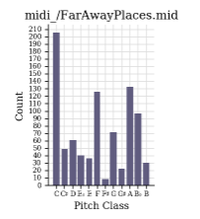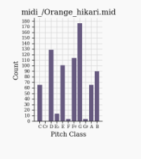

### Effort to correctly split data into 3 sets

We perform a train to validate split using keras.model.fit validation_split parameter instantiated with a 0.2 cut, or 80% to 20% data split between train and validate. Since we are using generative modeling we did not need a test data set. This is because generative modeling means building a model that can generate new examples that come from the same distribution set as the training data. This indicates that generative modeling is considered unsupervised learning.

### Effort to design/test neural network architectures -- 9. Effort to study Learning curves

Our model architecture uses four layer types. LSTM, Dropout, Dense, and Activation. From the beginning, we started out using generative models to produce new musical examples. We each developed a unique data set to train and validate the model, some of the various architectures used are discussed below. A variety of training yielded similar loss, val_loss, and song results so they’re omitted for brevity.

FIRST TRAINING: 6 songs

* model model = Sequential()
* model.add(LSTM(512, return_sequences=True, input_shape=(sequence_length, vocab_length)))
* model.add(Dropout(0.2))
* model.add(LSTM(512, return_sequences=False))
* model.add(Dropout(0.2))
* model.add(Dense(vocab_length))
* model.add(Activation('softmax'))
* model.compile(loss='categorical_crossentropy', optimizer=’rmsprop’, metrics = ['accuracy'])
* checkpoint = ModelCheckpoint(filepath, monitor=’loss’, verbose=0, save_best_only)=True, mode=’min’)
* callbacks_list = [checkpoint]
* history = model.fit(input_notes, output_notes, batch_size=128, epochs=50, validation_split=0.2, callbacks=callbacks_list)
* PARAMETERS: 3,692,756
* TRAIN_TIME: 1,149s
* loss: 1.7573 - acc: 0.4550 - val_loss: 6.4089 - val_acc: 0.0190

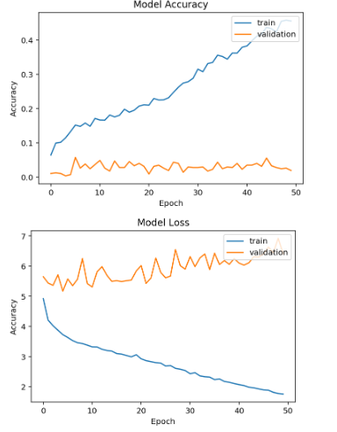

THIRD TRAINING: 30 songs

* model model = Sequential()
* model.add(LSTM(512, return_sequences=True, input_shape=(sequence_length, vocab_length)))
* model.add(Dropout(0.2))
* model.add(LSTM(512, return_sequences=False))
* model.add(Dropout(0.2))
* model.add(Dense(vocab_length))
* model.add(Activation('softmax'))
* model.compile(loss='categorical_crossentropy', optimizer=’rmsprop’, metrics = ['accuracy'])
* checkpoint = ModelCheckpoint(filepath, monitor=’loss’, verbose=0, save_best_only)=True, mode=’min’)
* callbacks_list = [checkpoint]
* history = model.fit(input_notes, output_notes, batch_size=1024, epochs=25, validation_split=0.2, callbacks=callbacks_list)
* PARAMETERS: 4,491,788
* TRAIN_TIME: 182s
* loss: 3.5774 - acc: 0.1478 - val_loss: 5.2775 - val_acc: 0.0398

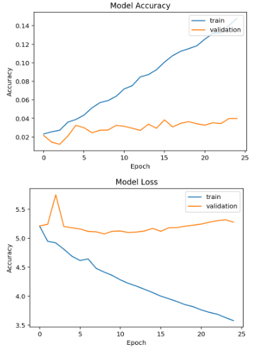

FOURTH TRAINING: 30 songs // used the adam optimizer, results not that great

* model model = Sequential()
* model.add(LSTM(512, return_sequences=True, input_shape=(sequence_length, vocab_length)))
* model.add(Dropout(0.2))
* model.add(LSTM(512, return_sequences=False))
* model.add(Dropout(0.2))
* model.add(Dense(vocab_length))
* model.add(Activation('softmax'))
* model.compile(loss='categorical_crossentropy', optimizer=’adam’, metrics = ['accuracy'])
* checkpoint = ModelCheckpoint(filepath, monitor=’loss’, verbose=0, save_best_only)=True, mode=’min’)
* callbacks_list = [checkpoint]
* history = model.fit(input_notes, output_notes, batch_size=1024, epochs=25, validation_split=0.2, callbacks=callbacks_list)
* PARAMETERS: 4,491,788
* TRAIN_TIME: 180s
* loss: 3.9828 - acc: 0.0956 - val_loss: 5.0917 - val_acc: 0.0316

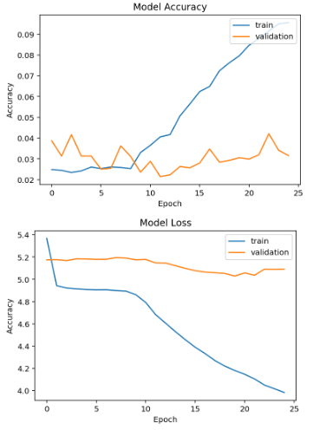

FIFTH TRAINING: 24 songs // This was after re-cleaning the dataset

* model model = Sequential()
* model.add(LSTM(1024, return_sequences=True, input_shape=(sequence_length, vocab_length)))
* model.add(Dropout(0.2))
* model.add(LSTM(1024, return_sequences=False))
* model.add(Dropout(0.2))
* model.add(Dense(vocab_length))
* model.add(Activation('softmax'))
* model.compile(loss='categorical_crossentropy', optimizer=’rmsprop’, metrics = ['accuracy'])
* checkpoint = ModelCheckpoint(filepath, monitor=’loss’, verbose=0, save_best_only)=True, mode=’min’)
* callbacks_list = [checkpoint]
* history = model.fit(input_notes, output_notes, batch_size=128, epochs=25, validation_split=0.2, callbacks=callbacks_list)
* PARAMETERS: 4,087,150
* TRAIN_TIME: 127s
* loss: 3.0036 - acc: 0.1133 - val_loss: 5.1772 - val_acc: 0.0248

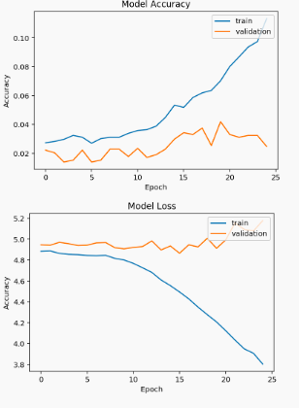

### Effort to evaluate your results

The model was evaluated with an 80/20 split of training and validation data. There were over 10 executions of the model yet the best distinct results for 1-10 were logged and used for comparisons. Overall, the model seemed to overfit during a lot of the training, this is somewhat expected in our case because the more memory cells we have increases the likelihood of overfitting. There is still great room for improvement for validation accuracy even though the baseline for the dataset has been beaten.

baseline: 0.0021

testing_acc: 0.4169 , val_acc: 0.0299

In my opinion the best output of the first ten tests in regards to sound was the sixth execution on 25 epochs:

6- train_output_SequenceLength=25, Epochs=25, Optimizer=rmsprop, no_dropout_layers, songs=24 LSTM=512, Batch=128

### Effort to benchmark your method / results

Compared to advanced models like *Ji-Sung Kim's* *DeepJazz and Google’s Transformer model, the* improved *Transformer-XL* the performance of our model wasn’t as profound. The model was able to produce decent sounding results, yet as a musician what I desire has yet to be achieved. Due to the time constraints we were unable to implement some of the complex algorithms and architectures used in Deep Jazz and the Transformer-XL models. Being able to comprehend the methods and architectures employed by the previous models would require many more hours of writing, debugging, testing the code, along with twice as much time training the model. Hearing the generated results from the two advanced models have enlightened us on the fact that there’s a lot of room for our model to grow.

### Documentation efforts

This report and the python notebook are documented well.

### Effort to document the training time

|  |  |  |  |
| --- | --- | --- | --- |
| **MODEL TRAINING** | **TOTAL PARAMS** | **TRAIN TIME: EPOCHS/\SECONDS** | **TRAIN TIME (MINUTES)** |
| FIRST: 6 FILES | 3,692,756 | 50/\1,149 | 19.5 |
| SECOND: 30 FILES | 4,468,739 | 25/\176 | 2.93 |
| FOURTH: 30 FILES | 4,491,788 | 25/\180 | 3 |
| FIFTH: 24 FILES | 4,087,150 | 25/\127 | 2.12 |

### Effort to study learning curves

SEE NUMBER 4.

### Effort to prepare a “reproducible” Python Notebook (ipynb) file

All files for this project, including a reproducible notebook are located in GitHub:

[https://github.com/code-front/JazzBot](https://github.com/code-front/BluesBot)

A direct link to the notebook is here:

[https://github.com/code-front/JazzBot/blob/master/DeepLearningModel.ipynb](https://github.com/code-front/BluesBot/blob/master/DeepLearningModel.ipynb)